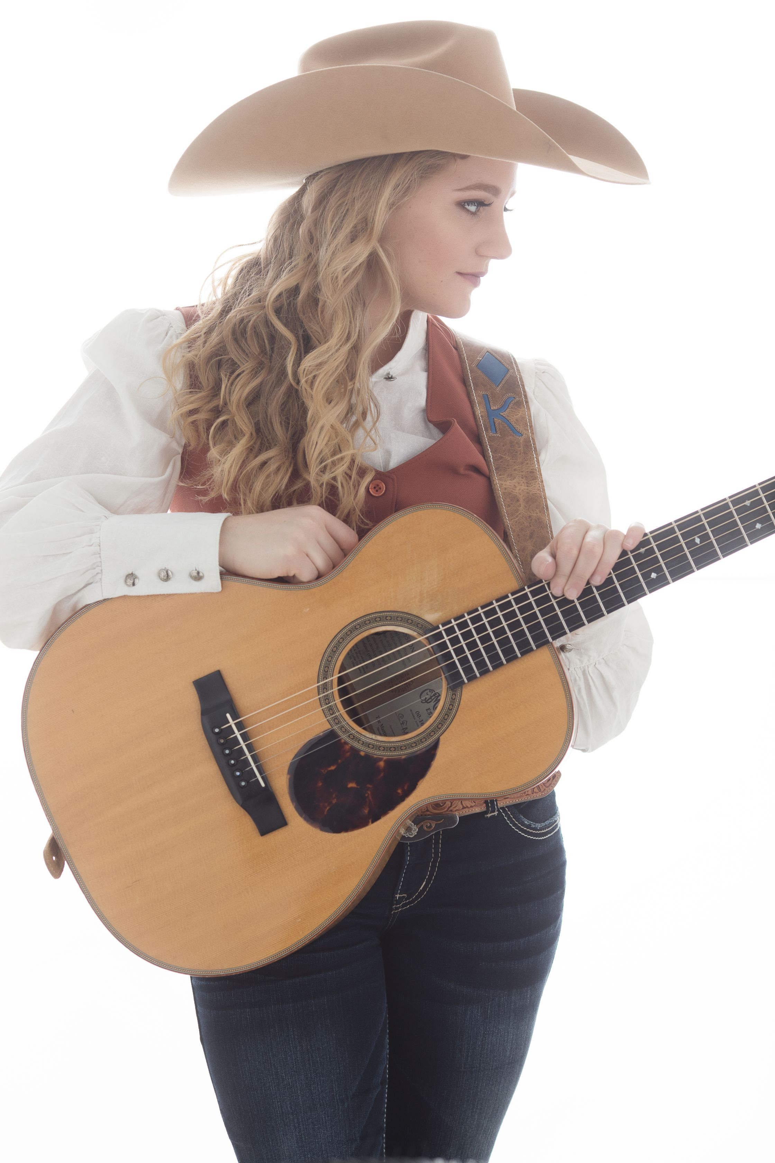KRISTYN HARRIS LONGER BIO

Texas-bred musical powerhouse, KRISTYN HARRIS, is noted for her shimmering vocals, solid swing rhythm guitar style, unique songwriting, award winning yodel, and captivating stage presence. At 25 years, she is the youngest person in history to be awarded the International Western Music Association Entertainer of the Year (2016, 2017, 2018, 2019). She is also a 4-time recipient of the IWMA Female Performer of the Year (2014, 2015, 2018, 2019), and was named the 2017 Ameripolitan Music Awards Western Swing Female Artist of the Year and the Pro Cowboy Country Artist Association’s 2017 Entertainer of the Year and Female Vocalist of the Year. Her singing has been praised as "timeless" with "the warmth and power of Texas sunshine". Most recently you might have seen Kristyn featured on ABC’s American Idol in 2018.
Though not raised in a musical household, Kristyn began singing and playing at age 14 when she felt strongly inspired to pick up a guitar - and it has rarely left her hands since. Discovering an instant passion, she launched into a headlong pursuit of the music that grabbed her and caused her to start playing; primarily the vintage arrangements, captivating chord structures, ranching themes and uplifting melodies that cornerstone western swing and western/cowboy music (later, throwing in tidbits of country, 1940s big band, gypsy jazz, and traditional folk song influences to her music, and building a gospel repertoire). Somewhere along the way it became her career path.

Songs of the western lifestyle have also gone hand in hand with her passion for land, livestock, and horses. Along with training her own horses, Kristyn has ventured into the beef cattle business, and has pursued her dream to become a professional trick rider – aka, gymnastics on a galloping horse – as a side hobby. These rural facets of her life commonly seep their way into her songs and shows. You can still find her combining these passions, too, when she rides into rodeo arenas on her once-wild mustang to sing the Star Spangled Banner.

In June of 2015 Kristyn released her 3rd solo album, "Down the Trail", which went on to be named the IWMA Western Album of the Year a few months later, as well as the Rural Roots Music Commission Pure Country & Western CD of the Year, and charted #1 on the western music DJ charts for Fall 2015. The same year, she became the Cowtown Society of Western Swing Rising Star of the Year. She has received the 2013 Cowboy Swing Album of the Year for “Let Me Ride”, the 2012 Crescendo (Rising Star) Award and 2012 Female Yodeler of the Year from the International Western Music Association. National television appearances, in addition to American Idol, include RFD-TV’s “The Penny Gilley Show”, “The Shotgun Red Variety Show”, and Nickelodeon’s popular game show, “Figure It Out”. She has been featured in multiple western documentaries, including a film that aired throughout 4 European countries in 2014.

Kristyn is packaged with an energetic and genuine style that makes her love of what she does evident and contagious. Keeping a heavy and widespread tour schedule – including her 4th European tour in 2018 - she frequently performs as a solo act and with larger ensembles.
Red Steagall says about Kristyn: “Kristyn Harris is one of the greatest talents that I have ever heard. Her heart is as big as Texas and it shows when she performs. She has a great career in store for her. I’m so proud that she’s my friend.” ABC News in Dallas called her “a rising star that has authenticity down to an art.”
And, the Arizona Cowboy Gathering put it best:
"This bundle of energy and talent is 'the rage' on stage from the east coast to the west and if you can stay seated when she finishes her performance you're prob'ly 'bout ready for the grave!!"
www.KristynHarris.com Follow on Facebook, Instagram & Twitter kristyn@kristynharris.com

